# Café Management System

### A MINI PROJECT REPORT

#### Submitted by

#### Group: G20

#### Project Group: PG16

**Purusharth Aggarwal, 2410991603**

**Ruhani Singal, 2410991624**

#### in partial fulfillment for the award of the degree of

## BACHELEOR OF ENGINEERING

***in***

CSE



**CHITKARA UNIVERSITY**

**CHANDIGARH-PATIALA NATIONAL HIGHWAY**

**RAJPURA (PATIALA) PUNJAB-140401 (INDIA)**

November, 2024

**TABLE OF CONTENTS**

|  |  |  |
| --- | --- | --- |
| **Sr.no** | **Section** | **Page no** |
| **1)** | **Abstract** | **1-4** |
| **2)** | **Introduction** | **4-5** |
| **3)** | **Problem Statement** | **6** |
| **4)** | **Key Features** | **7** |
| **5)** | **Technical Details** | **8** |
| **6)** | **Project Highlights** | **9-11** |
| **7)** | **Conclusion** | **12** |

**Abstract**

The Café Management System is a web-based application designed to streamline the management of café operations such as order placement, inventory tracking, billing, and customer interaction. Built using HTML, CSS, and JavaScript, this system provides an intuitive interface that enhances user experience while ensuring efficient back-end processing. The primary aim of the project is to demonstrate how a lightweight, browser-based application can effectively manage café operations without relying on complex server-side frameworks.

Objectives

1. Efficient Order Management: Provide an easy-to-use interface for placing and managing customer orders.
2. Inventory Monitoring: Track available stock and alert users when inventory is low.
3. Billing and Receipt Generation: Generate accurate bills and provide printable receipts for customers.
4. User Roles: Differentiate between user roles such as cashier, manager, and staff to assign permissions accordingly.
5. Responsive Design: Ensure the application is mobile-friendly, enabling use across various devices.
6. Data Persistence: Utilize local storage for temporary data management without a server.

**System Design:**

The system is developed using the following technologies:

1. HTML: Provides the structure and layout for the web pages.
2. CSS: Enhances the visual presentation, ensuring a professional and responsive design.
3. JavaScript: Implements the interactive and dynamic functionalities such as order handling, calculations, and user interactions.

**Features and Functionalities:**

1. Homepage: Displays an interactive menu with item categories, descriptions, and prices.
2. Order Placement Module: Allows users to select items, specify quantities, and view the order summary in real time.
3. Inventory Management: Tracks stock levels and displays warnings when items are low or out of stock.
4. Billing Module: Calculates the total price, applies discounts or taxes, and generates an itemized bill.
5. Admin Panel: Provides managers access to inventory data, sales reports, and user activity logs.
6. Responsive UI: Adjusts seamlessly for desktops, tablets, and smartphones.

**Technical Implementation:**

1. HTML: Semantic HTML5 elements are used to structure the pages, ensuring accessibility and maintainability.
2. CSS: Utilizes modern CSS techniques including Flexbox and Grid for layout, along with media queries for responsiveness.
3. JavaScript: Implements core functionality such as DOM manipulation, event handling, and data validation.
4. Local storage is employed to temporarily store order data and inventory status for real-time processing.
5. JavaScript objects and arrays handle data storage and retrieval within the application.
6. Interactive elements such as buttons, dropdowns, and input fields are implemented for smooth navigation and order customization.
7. Real-time feedback is provided through alerts, confirmations, and dynamic content updates.

**Benefits and Advantages:**

1. Cost-Effective: A purely client-side solution eliminates the need for expensive server infrastructure.
2. User-Friendly: A simple, visually appealing interface enhances user satisfaction and reduces training time.
3. Cross-Platform Compatibility: Runs smoothly on various devices without the need for additional software.
4. Data Security: Since the system does not rely on external servers, data privacy is better protected.

**Challenges and Solutions:**

1. Data Persistence Without Backend: The absence of a server necessitated the use of local storage for temporary data, with potential for future integration with cloud storage or databases.
2. Inventory Management Complexity: To ensure accurate stock tracking, robust JavaScript functions were developed to monitor inventory levels dynamically.
3. Integration with a cloud-based backend for permanent data storage and retrieval.
4. Addition of user authentication to enhance security and role-based access control.
5. Implementation of analytics and reporting features to provide insights into sales trends and performance metrics.
6. Integration with payment gateways for real-time transaction processing.

The Café Management System showcases the potential of using basic web technologies—HTML, CSS, and JavaScript—to create a functional, efficient, and user-friendly application for managing café operations. By leveraging client-side capabilities, this system offers a lightweight solution that can be enhanced further with server-side integration and advanced features.

**Introduction**

In the fast-paced modern world, cafes have become a cornerstone of social interaction and productivity. The need for efficient and seamless management of cafe operations is crucial for maintaining customer satisfaction and ensuring smooth workflows. This project, *Cafe Management System*, is developed using **HTML**, **CSS**, and **JavaScript** to address the core needs of a typical cafe, enhancing operational efficiency, user experience, and overall management.

The primary objective of this Cafe Management System is to streamline and automate the key processes involved in managing a cafe. These processes include order management, menu display, billing, and customer interaction. The system is designed to eliminate manual errors, reduce wait times, and provide a user-friendly interface for both cafe staff and customers.

The system aims to:

1. Provide an intuitive user interface for customers to place orders easily.
2. Facilitate order tracking and processing for staff to ensure quick service.
3. Automate billing processes to reduce errors and improve efficiency.
4. Display an interactive menu that can be dynamically updated.
5. Enhance customer engagement through real-time order status updates.

The project utilizes a combination of **front-end web technologies** to ensure a responsive, visually appealing, and interactive user experience:

1. HTML (Hyper Text Markup Language): HTML forms the backbone of the application, defining the structure and layout of the web pages. It includes elements such as forms for order input, tables for displaying menus, and containers for displaying dynamic content like order status.
2. CSS (Cascading Style Sheets): CSS is employed to enhance the visual appeal of the system. It ensures that the application has a consistent and modern design, making use of features like responsive grids, animations, and custom styling to create an inviting user interface.
3. JavaScript: JavaScript is used to add interactivity and dynamic functionality to the application. It handles real-time order processing, menu updates, form validation, and interactive elements like buttons and modals. JavaScript also enables asynchronous communication between the client and the server using AJAX, providing a seamless user experience.

The main purpose is to to digitize and simplify café operations by enabling smooth order placement, menu management, and transaction handling through a web-based interface and streamline and automate essential café operations, enhancing both efficiency and customer experience

**Problem Statement**

In traditional offline cafés, managing daily operations such as order-taking, menu updates, billing, and inventory tracking can be time-consuming and prone to errors. Manual processes often lead to challenges such as order mix-ups, delays in service, and difficulty in tracking stock levels. Additionally, the lack of a centralized system makes it harder to maintain consistent records, generate sales reports, or efficiently manage peak hours. These inefficiencies can negatively impact customer satisfaction and the overall productivity of café staff. Therefore, a streamlined solution is needed to automate and optimize key operations in an offline café environment. Offline cafés often rely on manual processes for order management, billing, and record-keeping, which can lead to operational inefficiencies. Common issues include delayed order processing, inconsistent menu updates, and human errors in billing or inventory tracking. These problems can result in long wait times, inaccurate orders, and poor resource management, ultimately reducing customer satisfaction and staff productivity. To address these challenges, an efficient system is needed to automate key functions, improve accuracy, and enhance the overall customer experience. Managing a café manually presents challenges in ensuring seamless communication between staff, especially during busy hours. Miscommunication can lead to incorrect orders, delayed service, and customer dissatisfaction. Additionally, manual record-keeping makes it difficult to generate accurate sales reports and track business performance. In offline cafés, updating menus or tracking inventory manually can be cumbersome and prone to delays. Staff often struggle to synchronize changes across different sections of the café, leading to outdated menu information and stock shortages, which can negatively impact customer experience and profitability.

**Key Features**

Key features of our café management system are:

* 1. Order Management system: Enables customers to place orders seamlessly, and staff to manage, update, or cancel orders in real time.
  2. Menu management: Allows dynamic updates to the menu, including adding, editing, or removing items, along with pricing changes.
  3. Inventory Tracking: Tracks stock levels in real-time, alerts staff when inventory is low, and helps maintain adequate supplies.
  4. Billing and Payment Processing: Automates bill generation, supports various payment methods (cash, card, digital wallets), and ensures accurate billing.
  5. Table Management: Helps allocate tables, manage reservations, and track table occupancy for efficient space utilization.
  6. Sales Reporting and Analytics: Provides detailed sales reports, revenue summaries, and analytics to track business

performance over time.

* 1. User Roles and Access Control: Offers different access levels for staff, such as administrators, servers, and kitchen staff, ensuring secure data handling.
  2. Customer Relationship Management (CRM): Maintains customer data, order history, and preferences to offer personalized service and loyalty rewards.
  3. Offline Functionality: Ensures continuous operation even without internet connectivity, syncing data once the connection is restored.

**Technical Details**

Technical details of our café management system are:

1. HTML (Hypertext Markup Language): Used to structure the content of the web application, including menus, forms, and buttons for order placement.
2. CSS (Cascading Style Sheet):Provides styling for the user interface, ensuring an appealing, responsive design with well-organized layouts and themes.
3. Java Script:Handles dynamic interactions, such as real-time updates of orders, validation of input fields, and event-driven behaviors
4. Single-Page Application (SPA) or Multi-Page Application (MPA):The system can be designed as either a single-page application with dynamic content loading or a multi-page application with separate pages for orders, menu management, and reports.
5. Local Storage/Session Storage: Data such as current orders, customer details, or menu items can be temporarily stored in the browser’s local storage for offline functionality.
6. Responsive navigation bar, dynamic menu display, order form, and bill summary section.
7. Modular code structure with reusable functions and components to facilitate future enhancements, like integrating a backend or adding new features.

**Project Highlights**

Main Page:

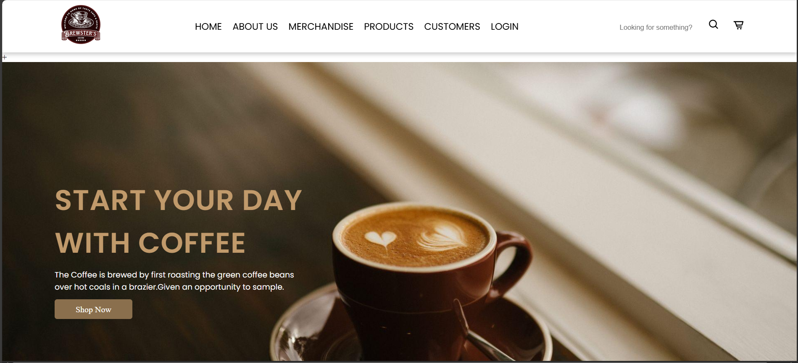

Products Page:

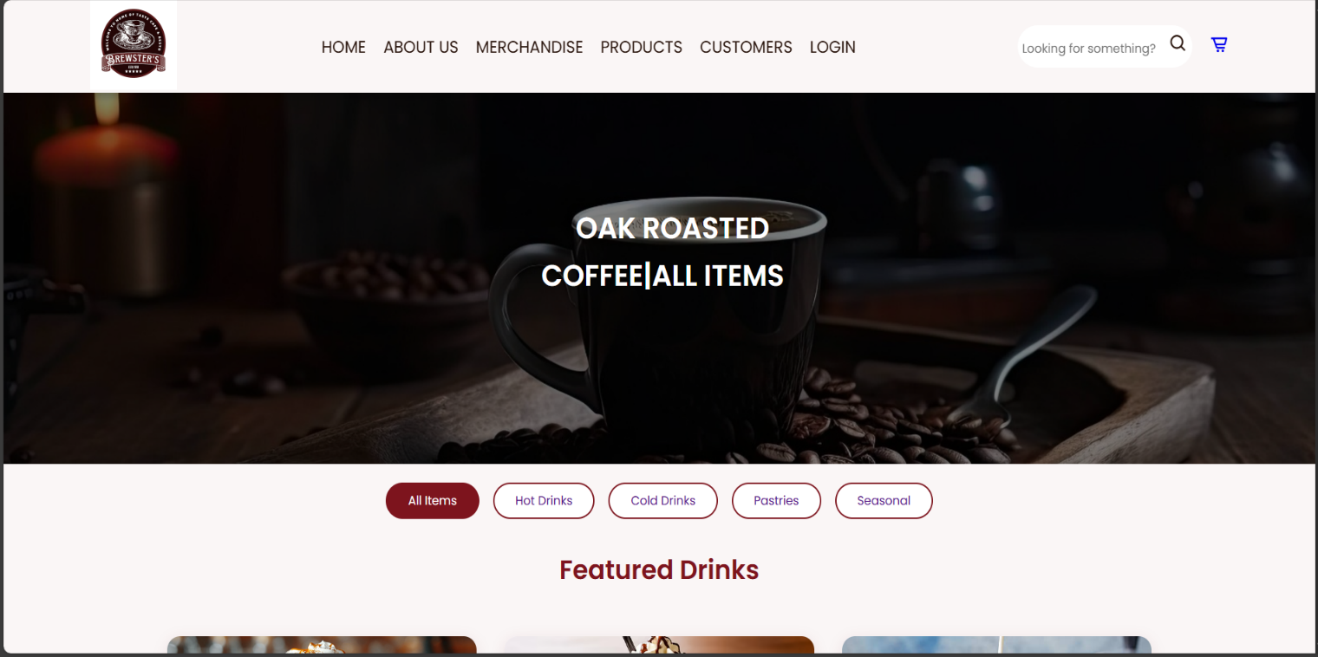

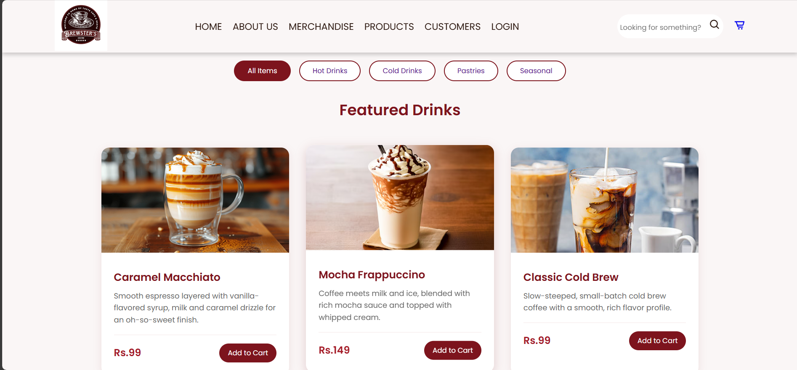

About us Page:

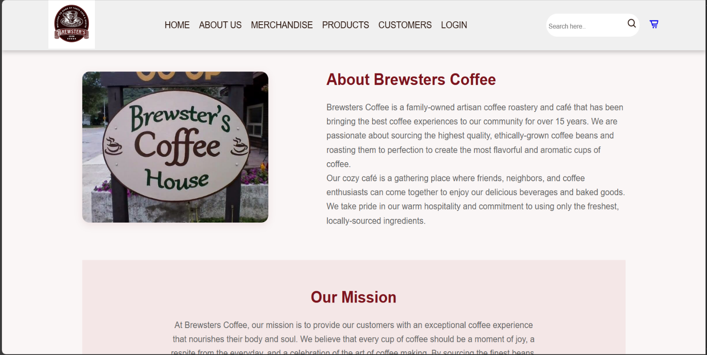

Main page footer:

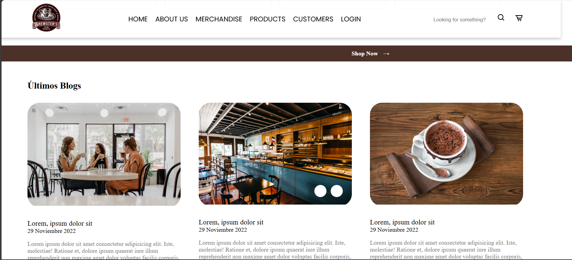

Cart page:

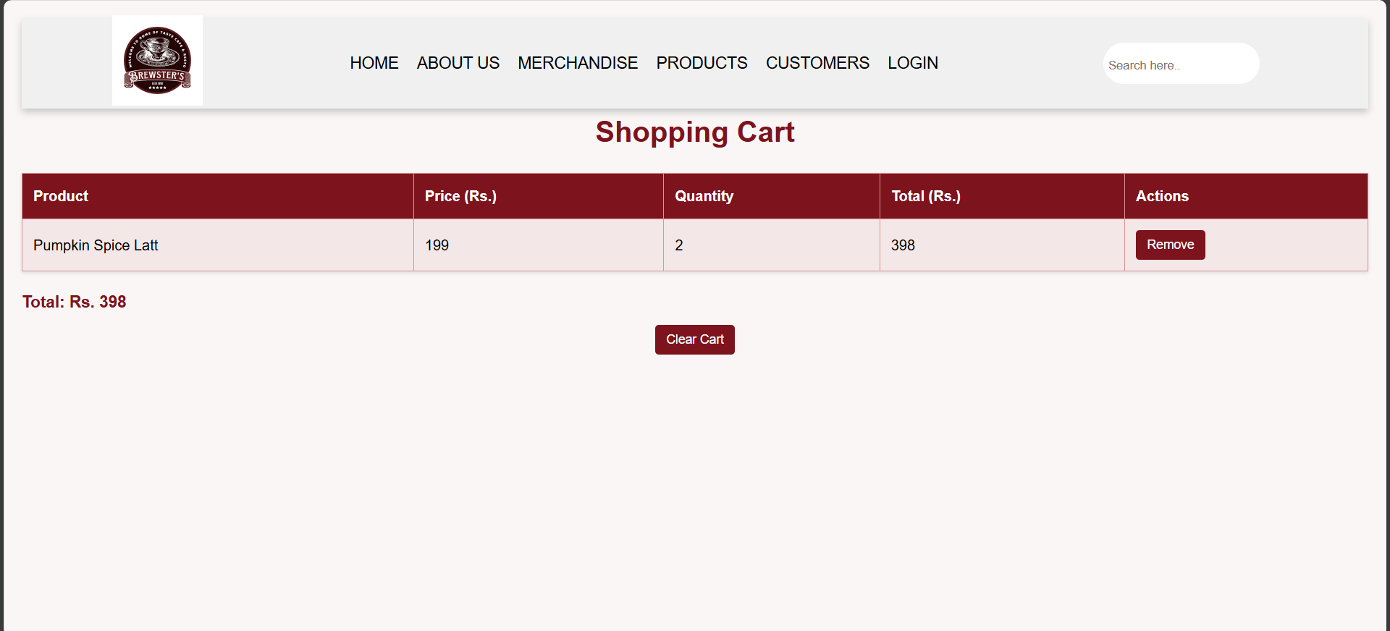

**Conclusion**

The **Café Management System** project demonstrates the practical application of web development technologies—**HTML**, **CSS**, and **JavaScript**—to create an efficient, user-friendly solution for streamlining café operations. The system addresses common challenges faced by traditional offline cafés, such as order management inefficiencies, manual billing errors, and inconsistent menu updates. Through this project, we have successfully developed a responsive, dynamic, and interactive application that enhances operational efficiency and customer satisfaction.

In conclusion, this project highlights the power and versatility of front-end web technologies in developing functional and visually engaging applications. The **Café Management System** successfully meets the primary objectives of enhancing operational efficiency, minimizing errors, and providing a seamless user experience. By leveraging HTML, CSS, and JavaScript, the project demonstrates how web technologies can be applied to solve real-world problems in the hospitality industry, paving the way for future advancements in digital café management solutions.

**References**

1. MDN Web Docs (Mozilla Developer Network)

URL: <https://developer.mozilla.org/>

1. W3Schools

URL: <https://www.w3schools.com/>

1. CSS-Tricks

URL: <https://css-tricks.com/>